Random Variables: variable determined by chance or event, a function that assigns values to each of an experiment's outcomes.
Random variables can be discrete or continuous.
Discrete Random Variables: the number of heads is a discrete variable. And because the number of heads results from a random process - flipping a coin - it is a discrete random variable.
Continuous Random Variables: In theory, his/her age can take on any value between zero and plus infinity, so age is a continuous variable. In this example, the age of the person selected is determined by a chance event; so, in this example, age is a continuous random variable.
Sometimes discrete variables can be finite or infinite.

Genrally distributions have cumulative and probability distribution function
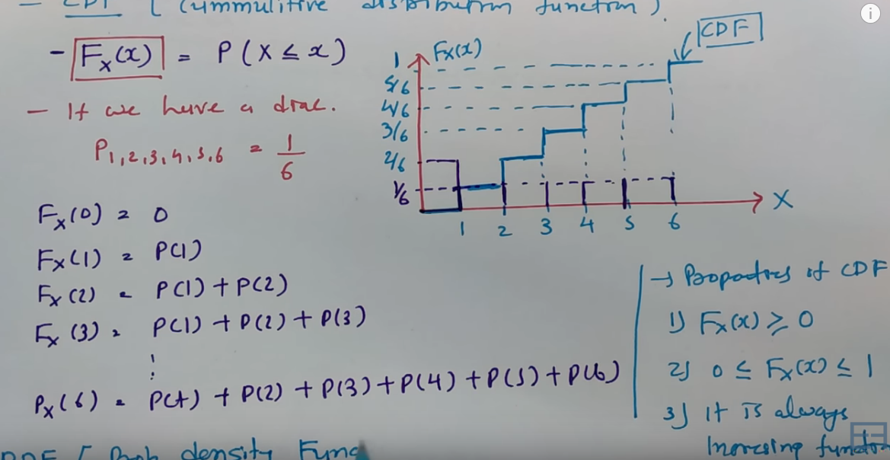

Discrete distributions:-
Uniform distribution
Non Uniform distributions
Binomial Distributions
Possion Distributions
Continuous Distributions:-
Uniform distribution
Non uniform distributions
Normal distributions
T distribution
Chi square distribution

Discrete distributions :-
Uniform distribution

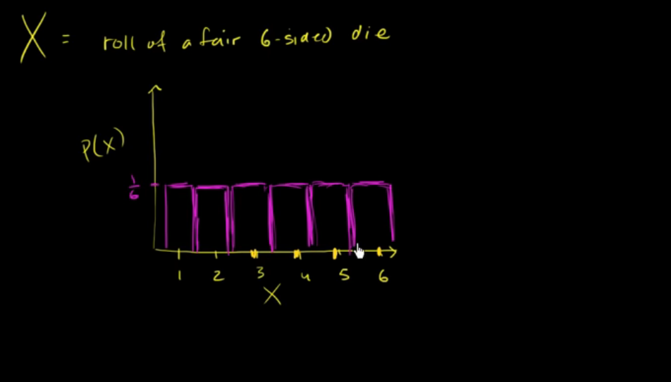
Here every item is equally likely.
When you roll a fair die, the outcomes are 1 to 6. The probabilities of getting these outcomes are equally likely and that is the basis of a uniform distribution.

A variable X is said to be uniformly distributed if the density function is:
The graph of a uniform distribution curve looks like
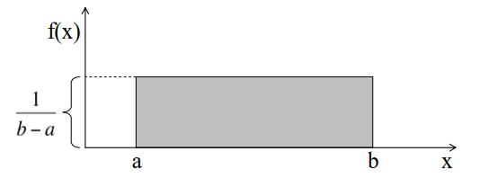
You can see that the shape of the Uniform distribution curve is rectangular, the reason why Uniform distribution is called rectangular distribution.

Example
Suppose a random number NN is taken from 690690 to 850850 in uniform distribution. Find the probability number NN is greater than the 790790?

Solution:
Given
Interval of number in probability distribution = [690, 850][690, 850]

Density of probability = 1850−6901850−690 =11601160

Now the probability is (790 < x < 850)
Interval of probability distribution of successful event = [790, 850][790, 850] = 6060
The probability ratio = 6016060160 = 110110

Hence the probability of NN number greater than 790790 = 0.1

Generating uniform random numbers:
# generate n random numbers between the default values of 0 and 1
runif(n)

# generate n random numbers between 0 and 25
runif(n, min = 0, max = 25)

# generate n random numbers between 0 and 25 (with replacement)
sample(0:25, n, replace = TRUE)

# generate n random numbers between 0 and 25 (without replacement)
sample(0:25, n, replace = FALSE)

The standard uniform density has parameters a = 0 and b = 1, so the PDF for standard uniform density is given by:
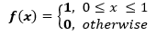

Binomial distribution : deals with number of success over a given number of trails
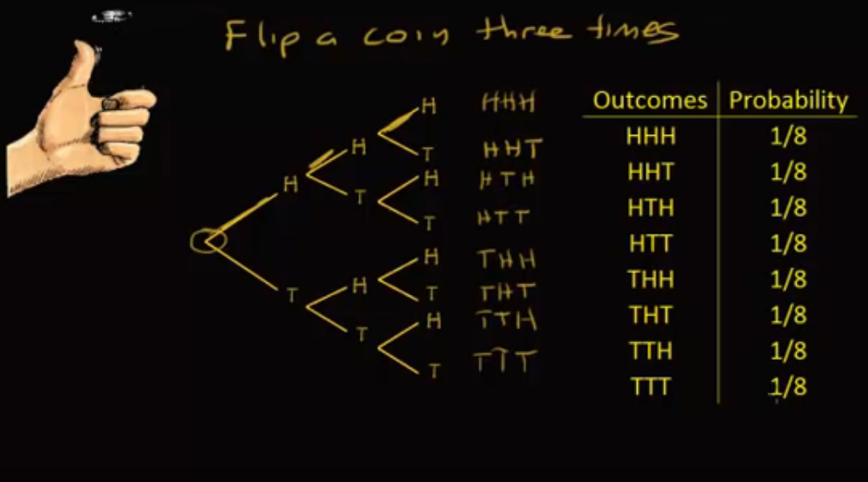
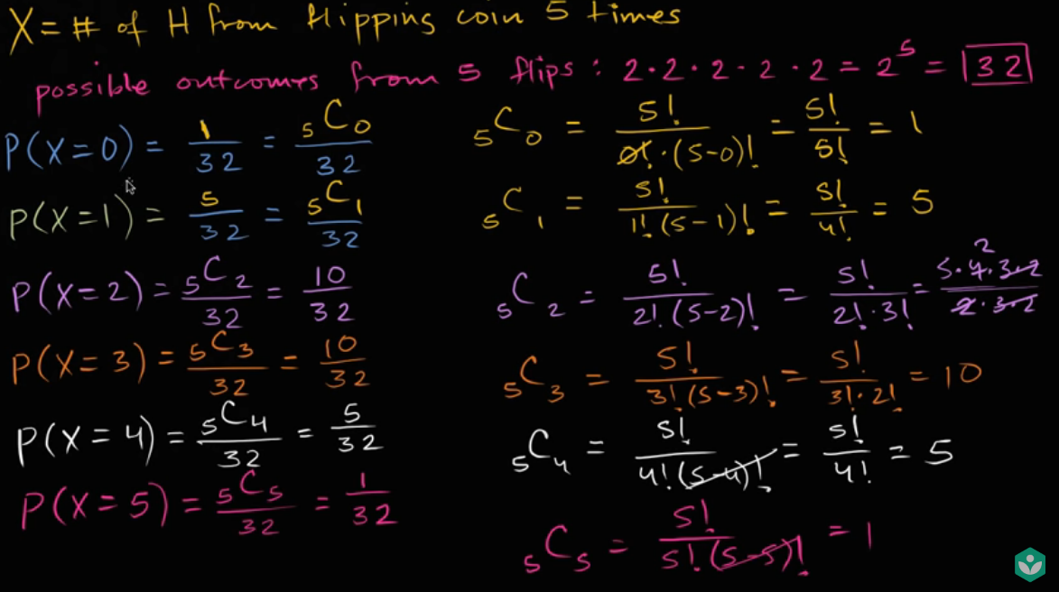
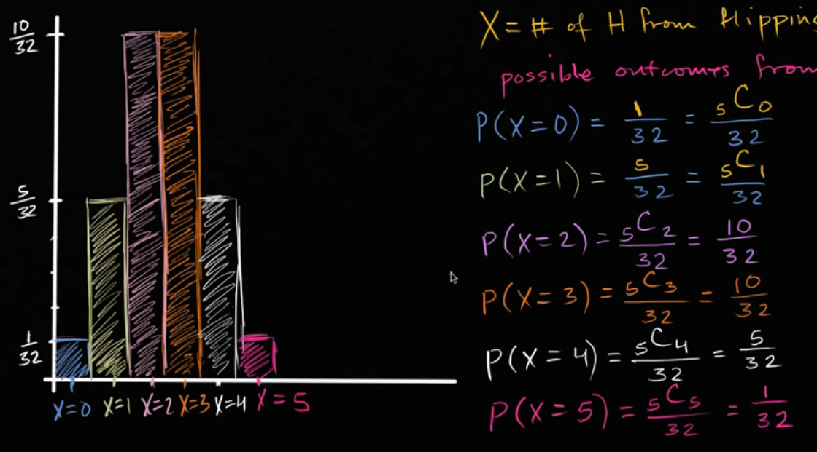
Above plot reprasents the symmetry with finite number is called the binomial distribution. Binomial distribution is the discreete version of normal distribution.
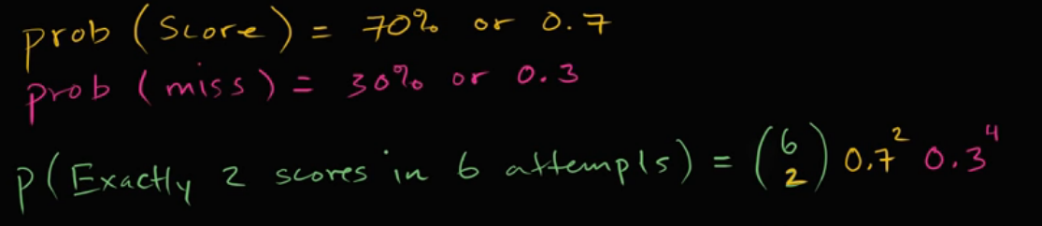
There are only two possible outcomes. Head denoting success and tail denoting failure. Therefore, probability of getting a head = 0.5 and the probability of failure can be easily computed as: q = 1- p = 0.5.
A distribution where only two outcomes are possible, such as success or failure, gain or loss, win or lose and where the probability of success and failure is same for all the trials is called a Binomial Distribution.
The outcomes need not be equally likely. Remember the example of a fight between me and Undertaker? So, if the probability of success in an experiment is 0.2 then the probability of failure can be easily computed as q = 1 – 0.2 = 0.8.
the properties of a Binomial Distribution are
- Each trial is independent.
- There are only two possible outcomes in a trial- either a success or a failure.
- A total number of n identical trials are conducted.
- The probability of success and failure is same for all trials. (Trials are identical.)

The mathematical representation of binomial distribution is given by probability mass function.
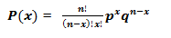
Mean (µ) = n*p
Variance -> Var(X) = n*p*q
# generate a vector of length n displaying the number of successes from a trial
# size = 100 with a probabilty of success = 0.5
rbinom(n, size = 100, prob = 0.5)

# generate CDF probabilities for value(s) in vector q
pbinom(q, size = 100, prob = 0.5) p(x) <=K

# generate quantile for probabilities in vector p
qbinom(p, size = 100, prob = 0.5)

# generate density function probabilites for value(s) in vector x
dbinom(x, size = 100, prob = 0.5)

Poissons Distribution: the likelihood of a number of events occuring within a given time intervel
Some more examples are
The number of emergency calls recorded at a hospital in a day.
- The number of thefts reported in an area on a day.
- The number of customers arriving at a salon in an hour.
- The number of suicides reported in a particular city.
- The number of printing errors at each page of the book.
A distribution is called Poisson distribution when the following assumptions are valid:
1. Any successful event should not influence the outcome of another successful event.
2. The probability of success over a short interval must equal the probability of success over a longer interval
Now, if any distribution validates the above assumptions then it is a Poisson distribution. Some notations used in Poisson distribution are:
- λ is the rate at which an event occurs,
- t is the length of a time interval,
- And X is the number of events in that time interval.
Here, X is called a Poisson Random Variable and the probability distribution of X is called Poisson distribution.
Let µ denote the mean number of events in an interval of length t. Then, µ = λ*t.
The PMF of X following a Poisson distribution is given by:
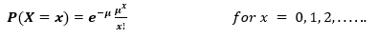
It is perceptible that as the mean increases, the curve shifts to the right.
The mean and variance of X following a Poisson distribution:
Mean -> E(X) = µ
Variance -> Var(X) = µ
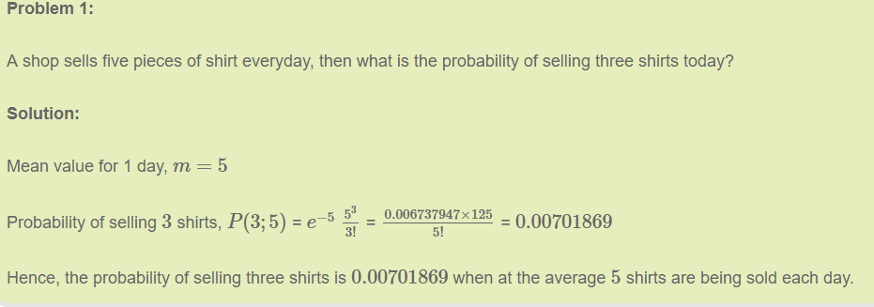

# generate a vector of length n displaying the random number of events occuring
# when lambda (mean rate) equals 4.
rpois(n, lambda = 4)

# generate CDF probabilities for value(s) in vector q when lambda (mean rate)
# equals 4.
ppois(q, lambda = 4)

# generate quantile for probabilities in vector p when lambda (mean rate)
# equals 4.
qpois(p, lambda = 4)

# generate density function probabilites for value(s) in vector x when lambda
# (mean rate) equals 4.
dpois(x, lambda = 4)

Normal Distribution :
Any distribution is known as Normal distribution if it has the following characteristics:
- The mean, median and mode of the distribution coincide.
- The curve of the distribution is bell-shaped and symmetrical about the line x=μ.
- The total area under the curve is 1.
- Exactly half of the values are to the left of the center and the other half to the right.
A normal distribution is highly different from Binomial Distribution. However, if the number of trials approaches infinity then the shapes will be quite similar.
The PDF of a random variable X following a normal distribution is given by:
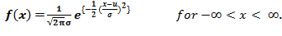
The mean and variance of a random variable X which is said to be normally distributed is given by:
Mean -> E(X) = µ
Variance -> Var(X) = σ^2
Here, µ (mean) and σ (standard deviation) are the parameters.
The graph of a random variable X ~ N (µ, σ) is shown below.
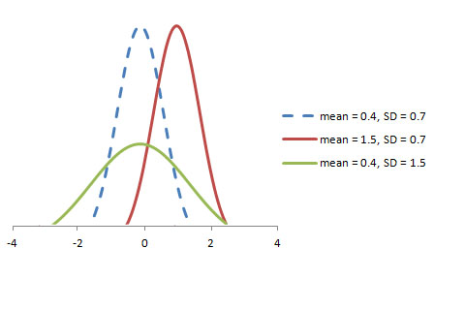
A standard normal distribution is defined as the distribution with mean 0 and standard deviation 1. For such a case, the PDF becomes:

# generate n random numbers from a normal distribution with given mean & st. dev.
rnorm(n, mean = 0, sd = 1)

# generate CDF probabilities for value(s) in vector q
pnorm(q, mean = 0, sd = 1)

# generate quantile for probabilities in vector p
qnorm(p, mean = 0, sd = 1)

# generate density function probabilites for value(s) in vector x
dnorm(x, mean = 0, sd = 1)

to generate 25 random numbers from a normal distribution with mean = 100 and standard deviation = 15
x <- rnorm(25, mean = 100, sd = 15)
summary(x)
You can also pass a vector of values. For instance, say you want to know the CDF probabilities for each value in the vector x created above:
pnorm(x, mean = 100, sd = 15)

T Distribution :-
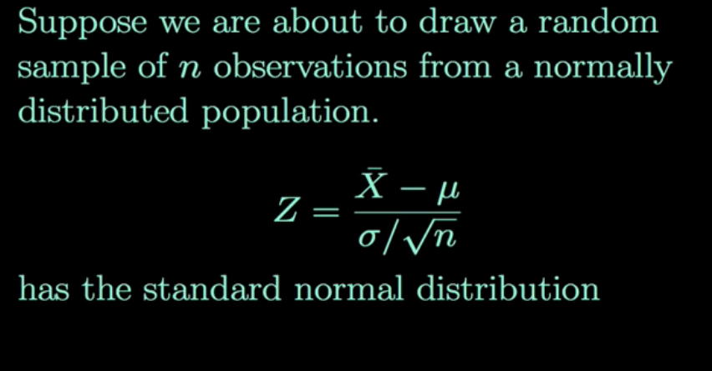
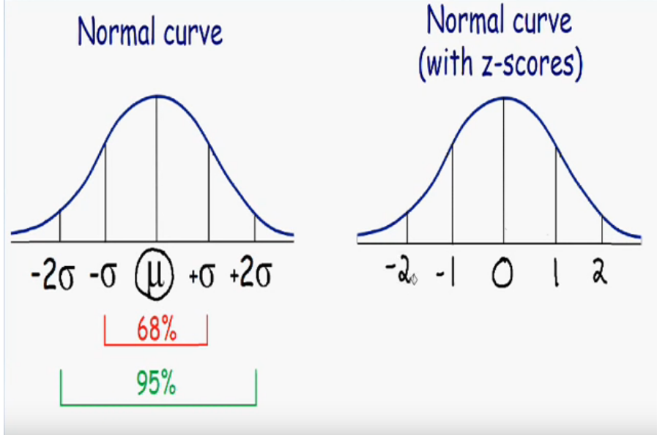
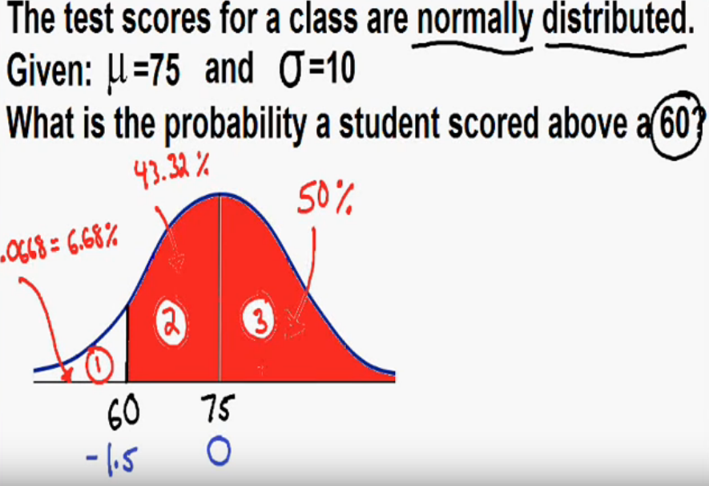
T Distribution :
The t distribution (aka, Student’s t-distribution) is a probability distribution that is used to estimate population parameters when the sample size is small and/or when the population variance is unknown.
According to the central limit theorem, the sampling distribution of a statistic (like a sample mean) will follow a normal distribution, as long as the sample size is sufficiently large. Therefore, when we know the standard deviation of the population, we can compute a z-score, and use the normal distribution to evaluate probabilities with the sample mean.
But sample sizes are sometimes small, and often we do not know the standard deviation of the population. When either of these problems occur, statisticians rely on the distribution of the t statistic (also known as the t score), whose values are given by:
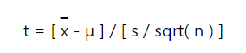
where x is the sample mean, μ is the population mean, s is the standard deviation of the sample, and n is the sample size. The distribution of the t statistic is called the t distribution or the Student t distribution.
The t distribution allows us to conduct statistical analyses on certain data sets that are not appropriate for analysis, using the normal distribution.
What is Z score:-

z-score
A z-score (aka, a standard score) indicates how many standard deviations an element is from the mean. A z-score can be calculated from the following formula.
z = (X - μ) / σ
where z is the z-score, X is the value of the element, μ is the population mean, and σ is the standard deviation.
Here is how to interpret z-scores.
- A z-score less than 0 represents an element less than the mean.
- A z-score greater than 0 represents an element greater than the mean.
- A z-score equal to 0 represents an element equal to the mean.
- A z-score equal to 1 represents an element that is 1 standard deviation greater than the mean; a z-score equal to 2, 2 standard deviations greater than the mean; etc.
- A z-score equal to -1 represents an element that is 1 standard deviation less than the mean; a z-score equal to -2, 2 standard deviations less than the mean; etc.
- If the number of elements in the set is large, about 68% of the elements have a z-score between -1 and 1; about 95% have a z-score between -2 and 2; and about 99% have a z-score between -3 and 3.

